Series: Starting Strong
Message: RL Vision—The Expansion Project January 6, 2013
_____________________________________________________________

The Story:
Joshua1, 5

The Win:

The Wall:

My response

Pray

Give

Act

Celebrate

The Expansion project:

Payer:
Philippians 4:6 Don’t worry about anything; instead, pray about everything. Tell God what you need, and thank Him for all He has done.

Each week as a church we will pray together for Gods leading in our lives and in our community: Here is a list of things to pray about this week.

Pray for God to strengthen your faith to move you to act in obedience to his leading.

Pray for God to bless your labor.

Pray for God’s protection for you and your family.

Pray for God to open doors of opportunity for Real Life Church.

Pray for barriers (walls) to come down:

- More space
- In peoples’ hearts toward God
- For more opportunity to show love to others

Pray for the leadership of Real Life for wisdom and courage.

Pray for people who are far from God that they may be drawn closer to Him.

Giving:
Luke 6:38 Give, and you will receive. Your gift will return to you in full—pressed down, shaken together to make room for more, running over, and poured into your lap. The amount you give will determine the amount you get back.

Begin praying and planning on how you can give to the expansion project.

What can I give?

What is my faith step in trusting God to do more than I think possible?

What resources do I have?

- Income
- Investments
- Overtime
- Tax returns
- Reducing spending
- Etc.

Acting:
Ephesians 2:10 He creates each of us by Christ Jesus to join Him in the work He does, the good work He has gotten ready for us to do, work we had better be doing.

- What steps of obedience is God Calling you to?
- What act of kindness comes to your mind right now?
- What Gifts and abilities has God given you? Are you using them for His purposes?

Celebrating:
1 Thessalonians 2:13 And now we look back on all this and thank God, an artesian well of thanks! When you got the message of God we preached, you didn’t pass it off as just one more human opinion, but you took it to heart as God’s true word to you, which it is, God himself at work in you believers!

Share this week on the 10,000 Reasons Project—What you are thankful for.

Practice daily giving thanks for:
- God supplying your needs
- People in your life
- Opportunities to love and serve
- Protection
- God blessing other people

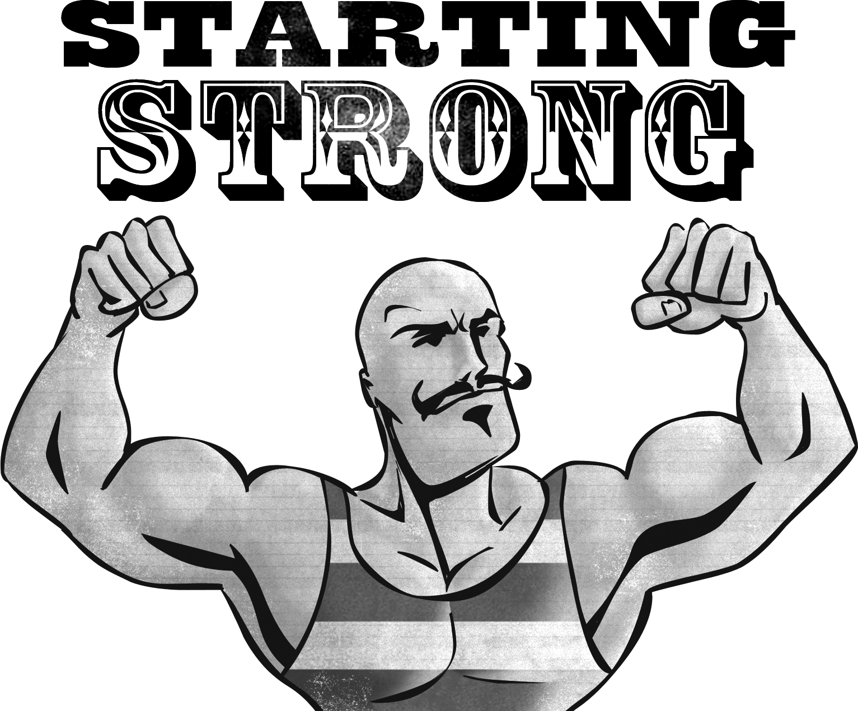

There is an old adage that says: ”If you do what you have always done, you will get what you have always got”—makes sense doesn’t it? Today, we start a very important series called STARTING STRONG. Do you want 2013 to be your best year ever? If you do, you must start strong. God’s word is full of life changing truth, that if we discover it and apply it wisely it will transform our lives in amazing ways. Are you ready for something better? Do you have friends who are ready for something better? Invite them to join you at Real Life for Starting Strong. Warning: you will be changed.
Topics:
- Storyboard your life: A personal vision for 2013- what is your preferred future?
- Strengthening the relationships that matter.
- Money: will you be master or slave in 2013?
- Supercharged life: releasing the power of the Holy Spirit in your life.
- Synergy: the power of doing life together.
- Hoarders: Getting rid of the things that hold you down and hold you back.
- Prayer: The GPS that keeps you on track.

